Introduction to the Teacher Research Project
Over the course of a five week instructional period, I was able to conduct an action research project that involved 22 first grade students who attend a Wake County school located in Knightdale, North Carolina. The action research project was conducted throughout a literacy block that began at 8:35 each morning and lasted 1 hour and 40 minutes. Collecting data through observations, anecdotal notes, student work samples, interviews, and mClass Dibels Next Nonsense Word Fluency assessments I was able to analyze my findings to reach a conclusion to my research question. Initially, as I brainstormed an area of research interest, I analyzed reading scores from my previous students and noticed a literacy deficit was fluency with nonsense words. Therefore, I chose to center my teacher research project on building the foundation of the alphabetic principle and blending skills by designing a plan that would allow students to build these skills independently; in addition to direct teacher instruction. Research provides evidence that supports a correlation between reading nonsense words and real words and the importance of the alphabetic principal in primary grades towards future reading success (Fien, Baker, Smolkowki, Smoith, Kame’enui & Beck, 2008). Integration of technology is a focus area in my professional growth plan, as well as the topic of my synthesis project for the New Literacies and Global Learning program. For that reason, I wanted to research how utilizing iPads during my literacy block could help support my students’ fluency with nonsense words; a focus that combined both of my interests. The research question that I proposed to myself and grade level team members is, “How can the use of iPads during Daily 5 word work support students’ literacy growth; specifically related to nonsense word fluency?” Choosing a component of Daily 5 is significant since Wake County has recently implemented this literacy framework in order to provide students with differentiated and choice driven literacy activities. Word work is one of the five rotation choices that a student may choose to attend and includes at least three choices of activities that typically include manipulatives.
My personal interest in the above research question is driven by the fact that I currently have six students on Personalized Education Plans (PEP’s) that focus on nonsense word fluency. In addition, my beginning of the year mClass Dibels Next data showed that 68% of my students received an “at risk” or “some risk” composite score; meaning they have multiple deficits in foundational skills necessary to become a successful reader. The beginning of year data indicates that 45% of the class received an “at risk” or “some risk” score on the nonsense word fluency measure. With such a high percentage of my class not meeting proficiency and the middle of year benchmark assessments around the corner, I felt that this topic was vital in my research. I was curious to investigate whether integrating a new variable, iPads, can support growth in the foundational skills needed in order to become proficient on benchmark measures. In addition, as a first year S.T.E.M (science, technology, engineering and math) school I have access to a cart of thirty iPads to use in the classroom that I felt should be utilized during instruction. Ideally, I would like to use my research to campaign for a 1-1 device ratio due to our low performing End of Grade (EOG) reading tests scores. Receiving more technology resources will also help our staff become more efficient in teaching the Common Core, as well as help equip our students with skills required to succeed in the 21st century.
I created three different activity choices for students to complete during Daily 5 word work. The application Educreations is a first grade friendly interactive whiteboard that allows students to record their voice and steps of a project. Using the application Educreations I created a game called “Change, Change, Change” in which partners are asked to begin with the word map on their interactive whiteboards. Twenty cards are stacked face down, each labeled with a specific instruction of which letter to manipulate in the consonant-vowel-consonant word. One partner picks up a card that may state, “change 1st letter”, “change vowel”, or “change last letter” and then manipulates the CVC word according the instructions. An alphabet strip is provided to scaffold for those students who need reminders of the different consonants and vowels. At the end of the 20 minute Daily 5 rotation, the partners save their work in Educreations in order for me to analyze their ability to manipulate beginning, middle, and end sounds. This activity allows students to practice blending nonsense words, and build a foundation of the alphabetic principle. The second activity choice that I created using Educreations is called “Create a Word” and is completed individually. This activity requires students to draw from three buckets full of letters labeled “consonant”, “vowel”, and “consonant”, write the letters on their Educreations whiteboard, and then record themselves blending the nonsense word together. To scaffold, I used yellow paper for the consonants and red paper for the vowels to help build an understanding that the vowel will always be in the middle of a CVC syllable. The third activity created for my action research requires students to sort ten CVC words depending on their vowel sound. In Educreations students draw a t-chart, write each word under the correct vowel sound, and then record themselves saying each word. This activity allows me to observe whether students can differentiate vowel sounds and read CVC words.
Schools around the country are trying to prepare their students to be successful in the 21st century, with this focus comes an abundance of recent literature regarding technology use in the classroom. However, Morrow & Gambrell (2011) note, “The pace at which technology evolves and changes renders an empirical evidence base almost impossible” which explains my struggle to find strong current data and research linking technology in the classroom with literacy success. Many of the articles that I discovered focused on the notion of digital literacy, effectiveness of technology in the classroom, how technology can increase student motivation, and different apps for a variety of content areas. The most helpful literature that I discovered was an article with research proving the validity of the Nonsense Word Fluency assessments as a screening for students with reading problems. Prior to this action research, I never understood the reasoning behind teaching students to blend nonsense words; a foundation of understanding that educators should be aware of before administering assessments. Although it is older research, the literature by Holum & Gahala (2001) helped guide my research by presenting information on the importance of how technology is used to enhance literacy and indicated that it must be authentic, meaningful, and conducted after initial classroom lessons on the specific literacy skill. I also used many websites that discussed the different levels of Bloom’s Taxonomy that can be integrated while using the application Educreations in order to help design the three work word activities for my action research.
Methodology
In order to validate my findings, I decided to divide my class in half based on their baseline Nonsense Word Fluency data from mClass Dibels Next. Half of my high, middle, and low students used the iPads every time they participated in word work during Daily 5. The other half of the students participated in the same three activities using paper rather than iPads. By forming two groups, I was able to compare students with similar baseline scores from the two different groups to determine whether using the iPad supported literacy growth. Using Wake County’s research based practices, I progress monitored each student in the class after every 9 instructional days using the Nonsense Word Fluency assessment. After each progress monitoring session, I had students fill in their growth of sounds per minute and growth of words per minute on a graph; see Appendix A. This activity was designed to help my students become more metcognitively aware of their goals. Using a spreadsheet, I recorded each student’s baseline Nonsense Word Fluency number of sounds per minute and number of words per minute, as well as each progress monitoring score received after the start of my action research project.
Another source of data collection that I used to assist with my research project was student work samples. Students were asked to save their work in Educreations after the completion of each Daily 5 rotation. Each iPad’s account was linked to my teacher account which gave me access to each student’s work sample throughout the duration of my research. This method of data collection allowed me to analyze specific errors and corrections in order to identify whether a student was demonstrating understanding of the alphabetic principal and blending skills that are necessary in order to meet proficiency on the Nonsense Word Fluency assessment. Analyzing student samples also helped drive my small group instruction by identifying students with similar needs to form small strategy groups.
I conducted many student interviews with each individual participant during my research. Prior to the implementation of my research project I asked each student if “jum” and “mzo” were consonant-vowel-consonant syllables and to explain their answer. I then proceeded to give students examples and non-examples of CVC nonsense words throughout the five weeks and recorded the student explanations. Later in the research project, my interviews included a question that asked students, “If this is not a CVC syllable, how could you rearrange the letters to make it a CVC syllable?” and I recorded student responses. I then conducted a post interview in which I asked the same initial question of whether or not “jum” and “mzo” were consonant-vowel-consonant syllables to examine student growth. Along with interviews, I keep detailed anecdotal notes and observations in order to gain insight into the students’ experiences with using iPads during Daily 5. I recorded student quotes, discussions between partners, and recorded the specific amount of time and days each student used the iPad to independently practice CVC words.
I collected both quantitative and qualitative data during the five weeks I implemented my action research; resulting in an abundance of anecdotal notes, interviews, recorded observations, student work samples, growth charts, and mClass data. In an attempt to become familiar with and organize my data, I created separate folders for each type of data, as well as organized the data by the date collected. Next, I took Koshy (2010) and Mills’s (2011) suggestion to color code my qualitative data in order to identify trends and themes across student observations. Using my observations, I color coded specific comments and partner talk in order to analyze any trends in conversation. I also analyzed how many students were able to correctly identify and explain a nonsense word during the first interview compared to the last interview. In addition, I analyzed how many students had the ability to manipulate the word “mzo” in order to create a CVC word. Using my anecdotal notes, I was able to determine the amount of time each student spent using the iPad during Daily 5 throughout the duration of my action research. From this information, I compared the amount of time each student used the iPad to their amount of growth on the Nonsense Word Fluency assessment in order to determine whether the amount of time spent using technology impacted the student’s performance. Analyzing student work samples, I was able to record each mistake that students made when blending CVC words in order to gain insight on the literacy skills they continue to need support with during small group instruction. From the student work samples, I was able to record how many students struggled with the word work activities due to dropping beginning or ending sounds, changing letter sounds as they blend, incorrectly identifying vowel sounds, or whether they still lacked a foundation of understanding a consonant-vowel-consonant syllable.
In order to analyze my quantitative data, mClass Dibels Next Nonsense Word Fluency results, I created tables using the data points collected during progress monitoring. I decided to represent my data using these visuals in order to display the growth of three progress monitoring scores in one location. I analyzed the growth of number of words per minute each student made over the course of 20 instructional days. I also decided to analyze the growth of whole words blended per minute, the number of words blended after isolating each sound per minute, as well as whether the amount of letter sound errors changed for each student. I then compared the table representing data from students who used the iPad during Daily 5 word work with the table that displayed data from the students who did not use the iPads.
Findings
As I began to progress monitor, I realized that many students’ number of sounds per minute on the mClass Nonsense Word Fluency Assessment was inconsistent. Therefore, I chose to analyze these data points from multiple angles by viewing number of whole words read per minute, number of words blended, and number of letter/sound errors in order to ascertain a trend in my data. Below are tables that represent the growth for each participant in each area analyzed based on the individual’s progress monitoring scores. Table 1 represents the data collected from the 11 students that used the iPads during Daily 5 word work. Table 2 represents the data collected from the 11 students that completed the same word work activities without the use of an iPad. Each student listed is in order beginning with the student who scored the lowest sounds per minute on the baseline progress monitoring to the student who scored the most amount of sounds per minute on the baseline scores.

Table 1
iPad Student Results

Student | Total Growth in Sounds per Minute | Total Growth in Words per Minute | Total Growth in Amount of Blended Words After Initial Isolation | More or Less Letter Sound Errors (Baseline compared with 11/14 data)
Student 1 | 5 | 0 | -1 | More
Student 2 | 3 | 0 | 7 | Same
Student 3 | 7 | 2 | 3 | Less
Student 4 | 3 | 1 | 3 | Same
Student 5 | 20 | 5 | 5 | Less
Student 6 | 20 | -12 | 8 | Less
Student 7 | 2 | -2 | -8 | More
Student 8 | 50 | 19 | 18 | Less
Student 9 | -8 | 1 | 9 | More
Student 10 | 13 | 3 | 3 | More
Student 11 | 15 | 6 | 6 | More

Table 2
Non-iPad Student Results

Student | Non-iPad Group Total Growth in Sounds per Minute | Non-iPad Group Total Growth in Words per Minute | Total Growth in Amount of Blended Words After Initial Isolation | More or Less Letter Sound Errors (Baseline compared with 11/14 data)
Student 1 | 0 | 0 | 0 | More
Student 2 | 9 | 0 | 0 | More
Student 3 | 12 | 3 | 3 | Less
Student 4 | 35 | 16 | 16 | Less
Student 5 | 10 | -8 | -4 | Less
Student 6 | 15 | 12 | 8 | More
Student 7 | 32 | 11 | 11 | Same
Student 8 | -5 | -2 | -5 | More
Student 9 | 3 | 2 | -5 | More
Student 10 | -3 | -3 | -3 | More
Student 11 | 28 | 10 | 10 | Less

Based on the above quantitative data, I was able to identify trends by comparing the results of the two groups that participated in my action research. Below are the trends identified:

Trend 1: The data shows evidence of multiple students regressing or not showing sufficient growth for five weeks of instruction in number of sounds per minute. However, looking closer, it is evident that some students showing regression in number of sounds per minute showed an increase in number of words per minute or number of blended words after initial isolation per minute; a skill I consider more important than randomly naming letter sounds. Figure 1 shows an example of a student whose data correlates with the above trend. Although this particular student dropped 8 letter sounds per minute, her last progress monitoring shows that she blended 9 more words in a minute and made less errors than at the beginning of the action research process.

Figure 1- Baseline data versus 11/14 progress monitoring data
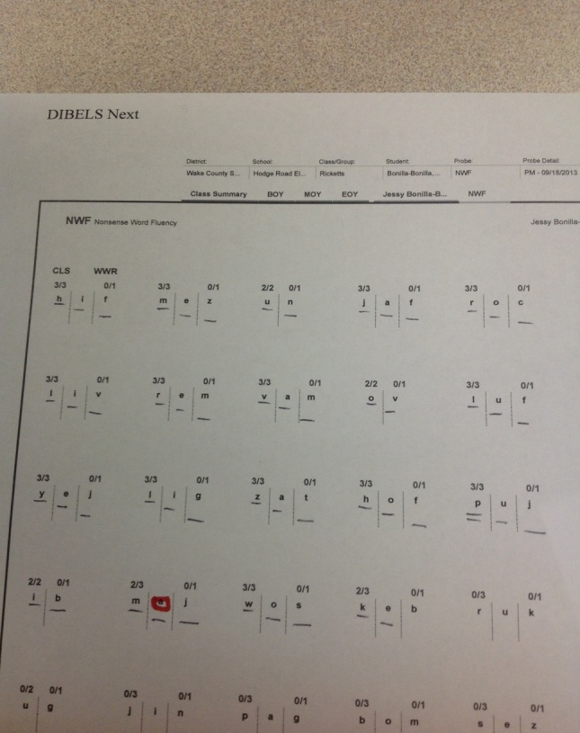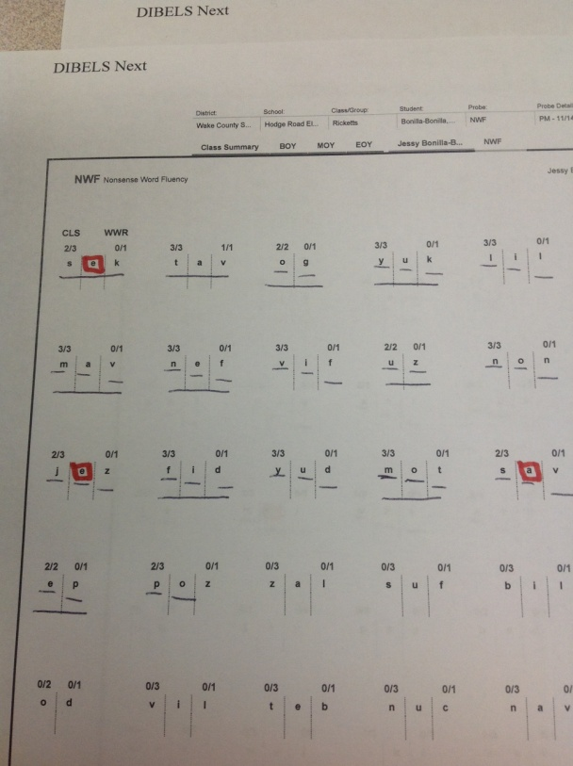

Trend 2: The use of an iPad during Daily 5 work word does not increase support or decrease support of literacy skills. The data collected from each group was inconsistent; a trend that I found surprising because I had prematurely jumped to the conclusion that iPads would be beneficial for literacy support. Both groups had five students that made more errors on the last data collection than their initial score in September; this could be correlated with the notion that as the study continued they begin to realize the assessments were timed. Both groups also had at least one student that showed negative growth in one of the areas analyzed. Comparing averages between the two student groups also lead to inconclusive data. The table below displays the findings that students in the iPad group benefited by having a higher average of words per minute and blending per minute. However, the students who did not use an iPad displayed more growth in sounds per minute on average. It was found that the amount of time using the iPad did not affect the amount of growth made.

Table 3
Averages
 | Growth in Sounds Per Minute | Growth in Words Per Minute | Growth in Blending Words Per Minute
Ipad | 11.8 Words | 3.7 Words | 4.8 Words
No-Ipad | 12.3 Words | 2.09 Words | 2.8 Words

Using qualitative data, a trend that was noted is students’ increased ability to explain why or why not a three letter word is a CVC pattern. Interviews at the beginning of the action research indicated that only 5 of the 11 iPad group participants could correctly explain what a CVC pattern was. Furthermore, only 3 of those students could explain how to manipulate the word “mzo” into a CVC pattern. Interviews conducted at the conclusion of the action research found that 10 of the 11 iPad group participants could correctly explain a CVC pattern and 9 of those students could explain how to manipulate the word “mzo” to create a CVC pattern. Therefore, it is concluded that student’s oral language and foundational understanding of CVC patterns benefited from the use of the iPad.
Observations found that 80% of the students in the iPad group made at least one comment self-correcting themselves during a word work activity. Comments such as “Wait that doesn’t make sense”, and “Oops, there is no vowel in the middle” were recorded. Additionally, 7 participants were observed peer tutoring another student on how to create a CVC pattern using the letter provided during word work. Therefore, this evidence suggests that students became more metacognitively aware of what they were learning, and why they were learning it.
Below are links to some of the student work samples that I have collected from my five weeks of research. From these examples, I was able to form small group instruction to support student learning.
The following is an example of a student who was practicing incorrectly throughout multiple activities; which indicates that he still did not have a clear understanding of CVC words. It is also evident that he is still struggling to blend three letter words as you can hear him changing some of the letter sounds when blending.
http://www.educreations.com/lesson/view/jaden/12736660/?s=J6jCcW&ref=appemail
Below is an example of a student who correctly completed the vowel sorting activity using Educreations. From her work sample, it is clear that she understands how to differentiate vowel sounds and blend sounds together to form a word.
http://www.educreations.com/lesson/view/rochelyn/12605524/?s=JlZnGz&ref=appemail
Next is an example of a student who is correctly building a CVC nonsense word, segmenting the individual sounds and then blending them together. On the whiteboard you can observe her placing dots under each letter and then swiping across the dots when blending.
http://www.educreations.com/lesson/view/daniela/12287332/?s=g2wo5x&ref=appemail
Last is an example of two students correctly completing the “Change, Change, Change” activity. You can observe how each word changes by one sound, the blending of sounds, and corrections that the students made to certain words throughout the sample. It is clear that they have built strong foundational understanding of how to manipulate sounds in words.
http://www.educreations.com/lesson/view/nathaly-jessy/12605533/?s=h6PtEd&ref=appemail
Discussion
The implications of my findings have had a significant impact on my personal instructional strategies in the classroom. Most importantly, discovering work samples that demonstrated some students had not yet built a foundation of the literacy skill I was researching forced me to take a step back and evaluate my whole group instruction. I viewed this set back in my research as a learning opportunity to re-teach by following Northrop & Killeen’s (2013) four step framework for using iPads in the classroom to build literacy skills. This framework ensured that I explicitly re-taught the concept of a consonant-vowel-consonant syllable whole group without the use of technology. Next, I re-modeled how to use the app Educreations and provided guided practice with the three word work activities used during Daily 5. Morrow & Gambrell (2011) emphasize the fact that teacher modeling needs to be paired with child involvement; therefore students followed along on their individual iPad’s step-by-step. Next, I allowed independent practice with the app and re-evaluated student samples to ensure they had a foundation of the literacy skills needed to correctly complete the iPad activities.
The implication that my research could have on others’ practices is equally significant. Using my research, I want to show teachers that holding students accountable for independent work during Daily 5 does not have to be in the form of worksheets. Many of my peers have regressed back to using worksheets in order to ensure students are engaged and on task and to provide documentation for teaching specific standards. However, my research has proven that you can use an iPad during word work and have the ability to view student work to hold them accountable. Also, the ability to evaluate student work samples to drive small group instruction is very valuable. As my findings were inconclusive, I would suggest that other educators conduct the same research in their classrooms over the course of an entire school year. With multiple cycles, I feel that a more defined answer can be found towards my research question.
As a result of my action research, I learned not to jump to conclusions regarding new programs, resources, or my students. I was quick to assume that technology was beneficial to student learning, however, I was unaware of the notion that students must have completely developed the literacy skill in order to practice correctly on their own. In addition, I learned that using manipulatives during word work that does not produce any visible student work can have severe negative impacts on student learning. If I did not have the opportunity to review student work samples, some of my students would be practicing incorrectly for the entire quarter. I have also learned not to assume that a student understands one literacy skills because they are proficient in many others. I discovered two students during this experience that I thought had mastered multiple literacy skills; however, their student work samples proved otherwise. I have learned that action research takes multiple cycles in order to gather sufficient data. This project made me realize that research takes time, pre-planning, and that careful data analysis can help you discover surprising information. In the future, I will become a more careful observer in the classroom, expect students to orally explain concepts, and implement peer tutoring during literacy based on my findings. I intend to continue using iPads during word work, analyzing student work samples, and re-teaching literacy skills prior to technology implementation if necessary. I hope to find data that correlates student literacy growth with the use of iPads and truly believe that, “As students become proficient readers, technology not only serves as a tool for continued literacy development, but it can also serve as a platform for using and showcasing literacy skills” (Morrow & Gambrell, 2011, p. 374).

Resources
Fien, H., Baker, S. K., Smolkowski, K., Smith, J. L., Kame’enui, E. J., & Beck, C. T. (2008). Using nonsense word fluency to predict reading proficiency in kindergarten through second grade for English learners and native english speakers. School Psychology Review, 37, 391-408.
Holum, A., & Gahala, J. (2001). Critical issue: Using technology to enhance literacy instruction. North Central Regional Educational Laboratory, 2-15. Retrieved from http://www.ncrel.org/sdrs/areas/issues/content/cntareas/reading/li300.htm.
Koshy, V. (2010). Action research: For improving educational practice. (2nd ed.) London: Sage Publications Inc.
Mills, G. (2011). Action research: A guide for the teacher researcher. pp. 120-150). Upper Saddle River, NJ: Pearson.
Morrow, L. M., & Gambrell, L.B. (2011). Best practices in literacy instruction (4th ed.). New York, NY: The Guildford Press.
Northrop, L. & Killeen, E. (2013). A Framework for using iPads to build early literacy skills. The Reading Teacher, 66(7), 531–537. doi: 10.1002/TRTR.1155

Appendix A

